FAMILY AND COMMUNITY VISIONING (FCV) MODULE
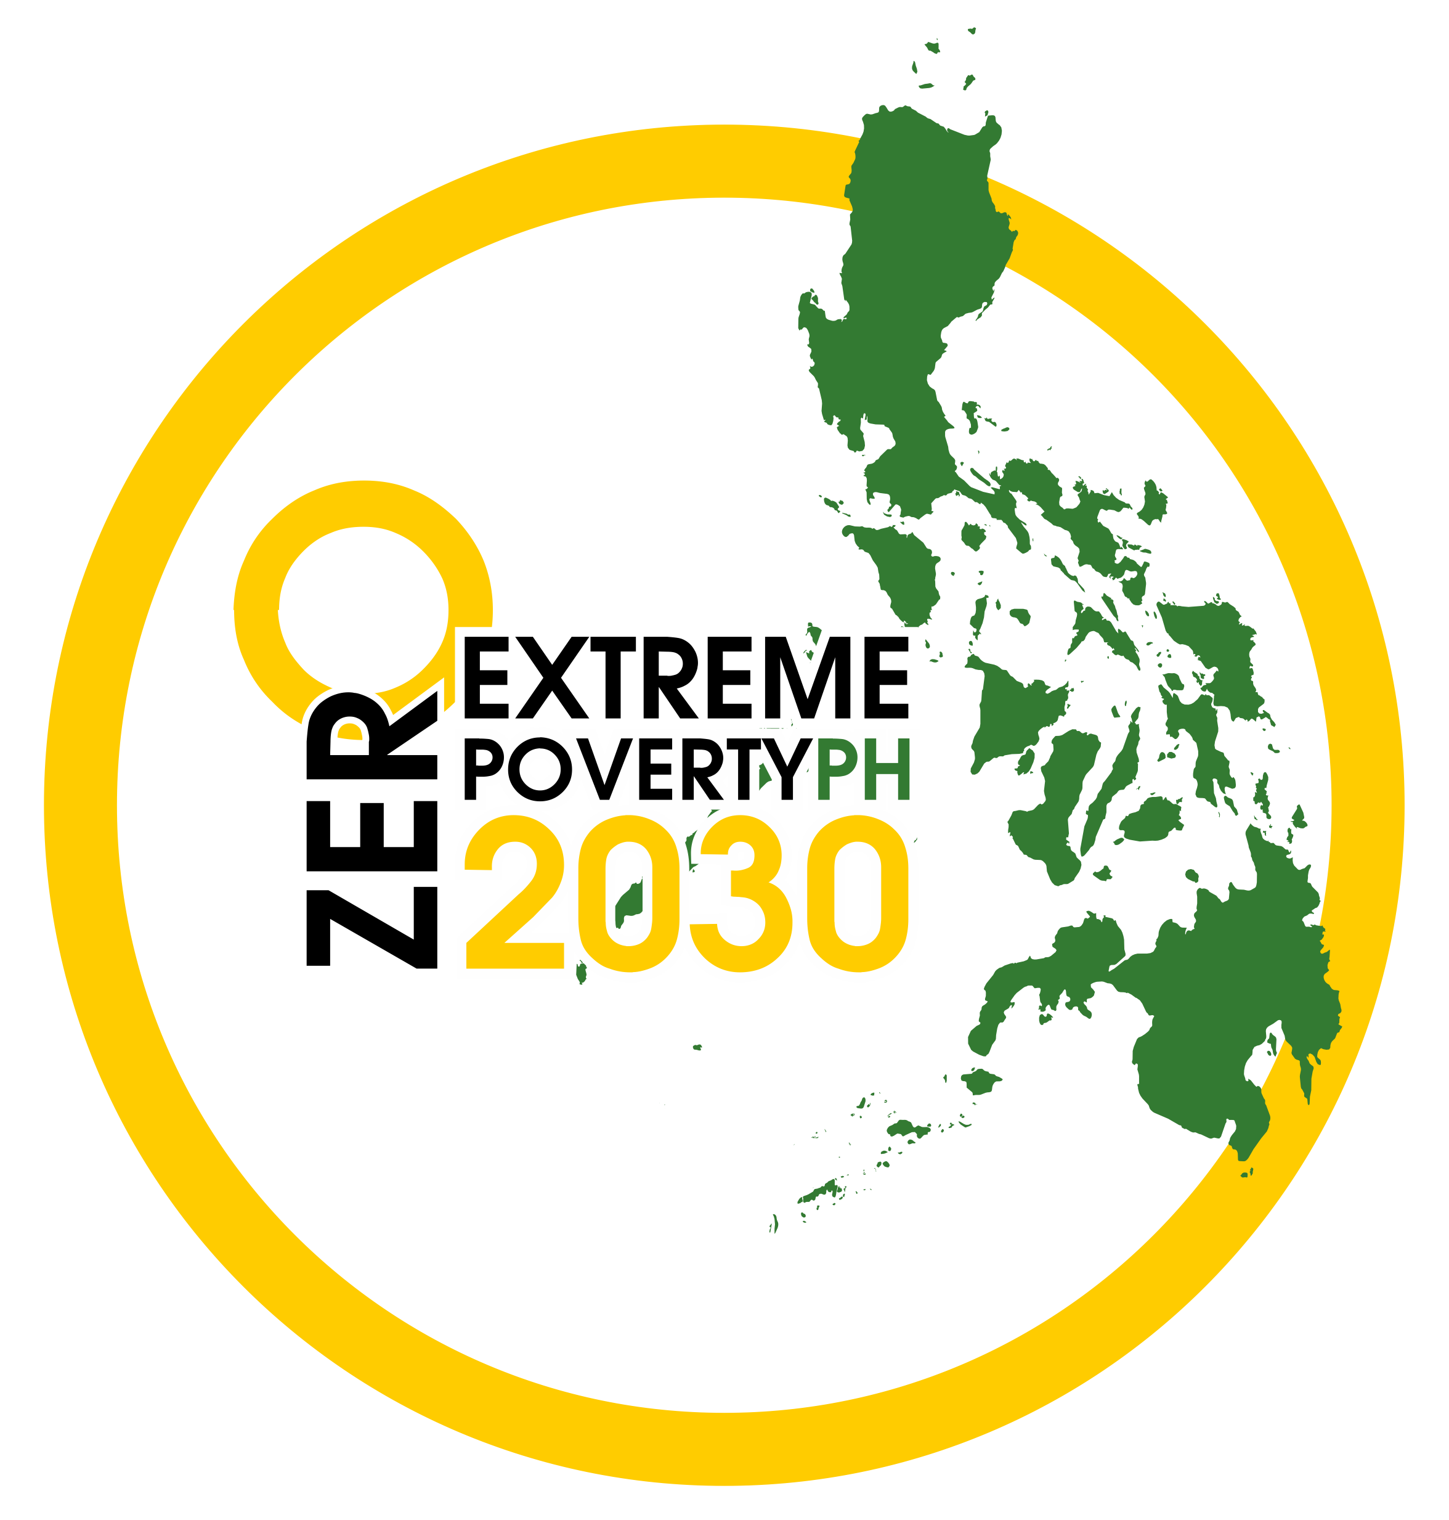

- RATIONALE / CONTEXT

The Family and Community Visioning (FCV) Module is patterned after the Participatory Visioning and Planning (PVP) Workshop Module of the Partnerships for Indigenous Peoples Cluster (formerly Peace and Human Security Cluster) of ZEP. While the PVP’s target participants are IP communities, the FCV was drafted for any type of community, with or without an organized group.

The FCV was also conceptualized for the Zero Extreme Poverty (ZEP) 2030 Movement because the lead convenors wanted its partner communities to be engaged in the planning process. This is a module that may be used to achieve that objective.

The FCV is intended to be conducted after the community mapping exercise. This is so that the mapping results may be validated.

The FCV may be completed in one day to maximize the presence of all the participants. This is also in consideration of limited/minimal resources. However, in some cases, due to travel of some participants, it may be necessary to conduct the session from lunch on the first day to end with lunch on the second day.

This module was drafted by the Association of Foundations (AF).

- OBJECTIVES

FCV has the following main objectives:
- To validate the mapping results
- To engage the various stakeholders and get the hopes and dreams of families and communities
- To come-up with family/community plans and activities

- OUTPUTS

The following are the expected outputs of the module:
- Validated mapping results
- Community development plan
- ZEP interventions/programs

- FACILITATORS & PARTICIPANTS

The facilitators could be any or all of the following:
- Local Convenor and/or another Local Partner
- Cluster Lead
- TWG or ZEP Secretariat

It may help to have someone in the team who can speak the local language and has some experience as a workshop facilitator.

The expected participants which may number around 20-40 are the following:
- Family heads or representatives, including the youth (may need some guidelines such as gender balance, etc.)
- Barangay leaders
- Other community stakeholders – other parents and youth, teachers, representatives of community-based organizations

A meeting with the LGU and NGAs may be arranged separately to encourage participating families to share more openly during the FCV.

- LOGISTICS

The Local Convenor will be requested to handle preparations with support from ZEP TWG, Secretariat and Cluster Leads. Workshop materials will include:
- Registration sheets
- Name tags
- Meta cards
- Pentel pens
- Masking tape and scissors
- White board and markers
- Laptop and LCD projector
- Manila papers
- Mapping Results
- ZEP Overview presentation
- Sound system (depending on the size of the group)

- WORKSHOP PROGRAM FLOW
Introduction and Welcome
Expectation setting
ZEP Overview and FCV Objectives
Family and Community Visioning Exercise
Resource Mapping
Community Development Plan
ZEP Partnership and Stakeholders Commitment
Way Forward

- WORKSHOP PROCESS

[8:00 – 8:30 am] Session 0: Registration

[8:30 – 8:45] Session 1: Introduction and Welcome
A welcome message may be done by the local convenor or by any other person that may be selected by the local convenor. After which, there will be an introduction of all the participants. This may be in the form of saying one’s name and the organization or any other institution. This may also be done per family.

Guide: Please state your name, nickname, family members, or organization.

[8:45 – 9:15] Session 2: Expectation setting
This is to level-off expectations among the participants. Depending on the number of participants, this may be done individually using meta cards or by groups and coming up with 5 ideas per group, still using meta cards. A synthesis should be done as well as a connection with the next session on objectives.

Guide: When you were asked to attend today’s activity, what were your expectations? What did you want to achieve? Why did you decide to be here?

[9:15 – 9:45] Session 3: ZEP Overview and FCV Objectives
The ZEP history and overview will then be presented together with the objectives of the Family and Community Visioning workshop. This is also to ensure that expectations are clear with all the participants.

Guide: Local Convenor or Cluster Lead/Coordinator or ZEP TWG/Secretariat makes a brief presentation on ZEP and the tying-up the objectives with the expectation setting session results.

[9:45 – 10:00 Snacks]

[10:00 – 11:00] Session 4: Presentation and Validation of Mapping Results
The assumption here is that a mapping has been conducted with the identified community. This could be the results of PPI or of any other tool, or the most recent data available locally such as from the Community-Based Monitoring System (CBMS). The data should be presented in such a way that will help the community understand the general situation. At the same time, this session will also provide participating families the opportunity to share how they see their current situation.

Guide: Local Convenor or the Local Partner that helped with the mapping presents mapping results. The facilitator may then entertain questions or clarifications from the participants. He/She may also try to validate the results by asking if the data/information is correct. It may be important to emphasize that this serves as baseline data and therefore it serves as a benchmark for future interventions and activities.

[11:00 – 11:45] Session 5: Family and Community Visioning Exercise
Given the results of the mapping and the discussion from the previous session, a visioning process follows. The main objective is for the families to articulate their aspirations and, collectively as a community, dream a better future. This may be done per family at first and then as a community.

Guide: Aspirations and dreams of a family and the community it belongs
Mga pangarap ng bawat pamilya / Mga pangarap ng inyong komunidad

In groups of 5-7 pax, answer the following questions:
- What are the aspirations/dreams of your families? (top 7)
- For your community, what are your aspirations/dreams? (top 7)
Note: Use one color of meta card for each question. Also, a way of ranking the priorities will be the number of cards per theme when clustered together. The clustering may be done during the next workshop session.

[11:45 – 12:30] Session 6: Resource Mapping
Given the results of the visioning exercise, it is important to note the available family and community resources. This is to highlight that there are resources within each family and community.

Guide: Using the same grouping, ask the following questions:
- What resources are available in each family?
- What assets may be found in your community?
Note: Use one color of meta card for each question. The clustering may be done during lunch break.

[12:30 – 1:30 pm Lunch]

[1:30 – 3:00] Session 7: Community Development Plan
This session will have the synthesis of the previous 2 sessions and link it with the mapping results. This is to highlight that while there may be extreme poverty in the community, there are available resources which help bridge the gap in achieving the family and community hopes and dreams.

Guide: The facilitator presents the synthesis of the 2 sessions namely the dreams and hopes as well as the available assets and resources. The facilitator also goes back to the mapping results to present hopes/dreams-gaps-resources. This is when a call to help goes out to the various stakeholders. The facilitator then seeks answers from the participants. This is when the local convenor can also present possible interventions and activities.

[3:00 – 4:00] Session 8: Family, Community and ZEP Partnership and Stakeholders Commitment
This session is more a commitment expression or a ritual for the partnership. This session will reiterate the value of working together, of “bayanihan”.

Guide: It is during this time that some of the stakeholders will make pledges. Then a ritual or a commitment expression among the various stakeholders can be done.

[4:00 – 4:30] Session 9: Way Forward and Closing
A synthesis will be provided on the events of the day as well as the way forward. As much as possible, the next steps to be provided are specific and concrete, with a corresponding timeline. A closing message will be rendered by the local convenor or organizer.

[4:30 Snacks]

